Install Inkscape & Bachin Maker Tool

**Download Inkscape, download version 0.92, 32bit or 64bit are both fine.**

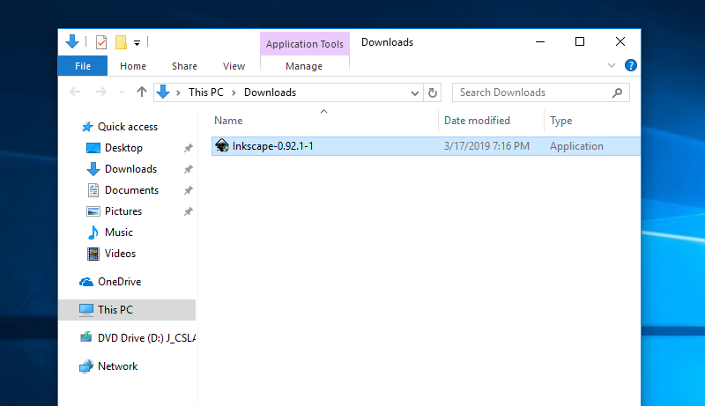

**Say Yes to User Account Control**

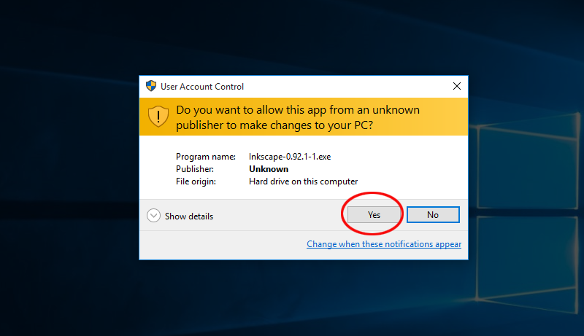 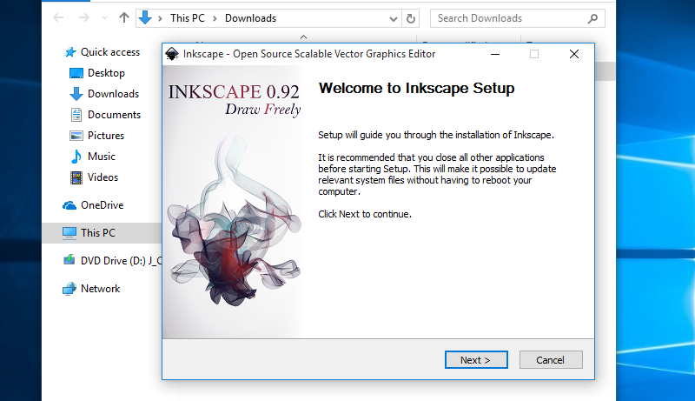

**Default is ok**

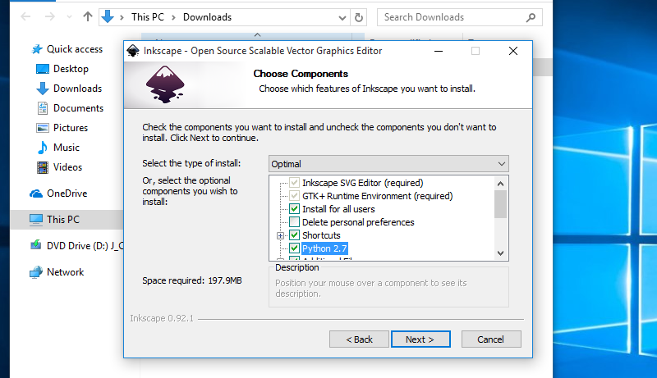 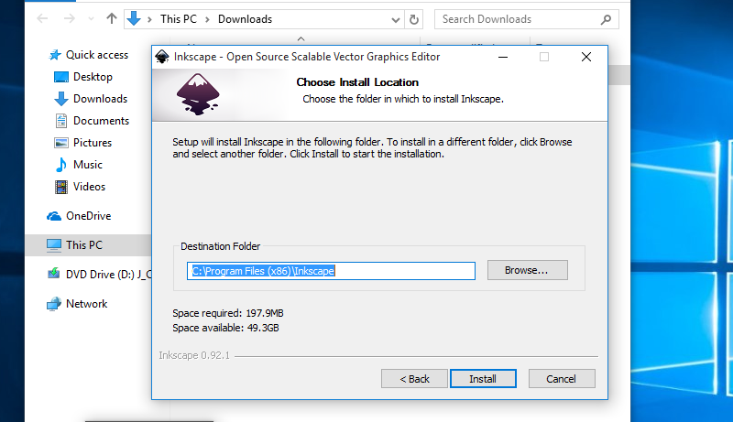

**We will run it later**

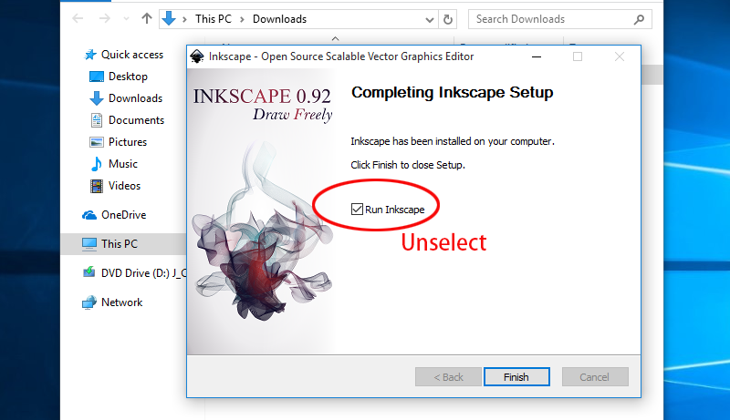

**Download**[**inkscape_bachin_plugin.zip**](http://bachinmaker.com/wiki/lib/exe/fetch.php?media=inkscape_bachin_plugin.zip)**, unzip it**

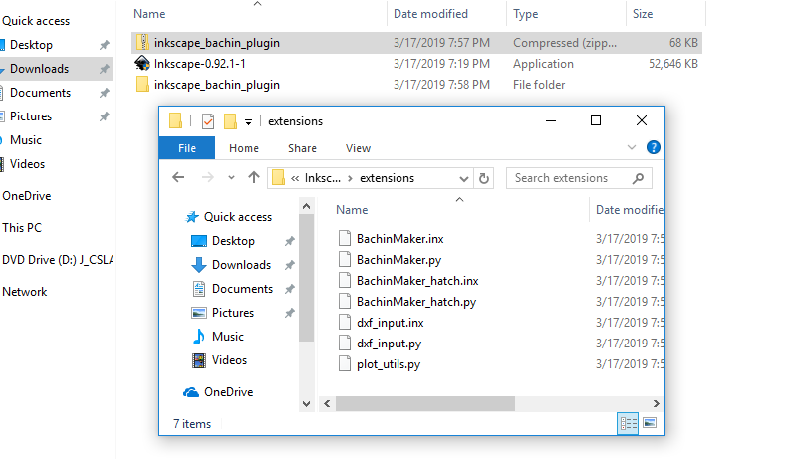

**Open inkscape install location**

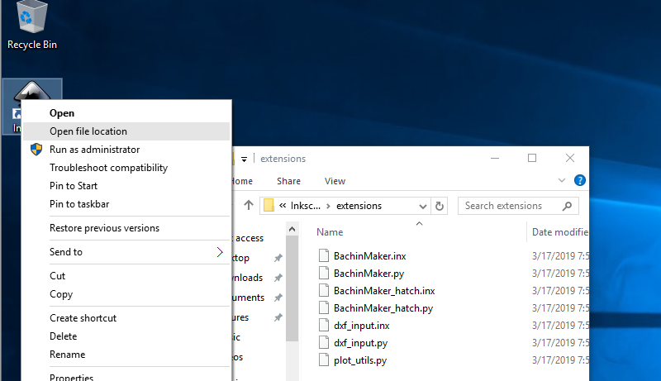

**Locate {Inkscape Install Folder}\share\extensions**

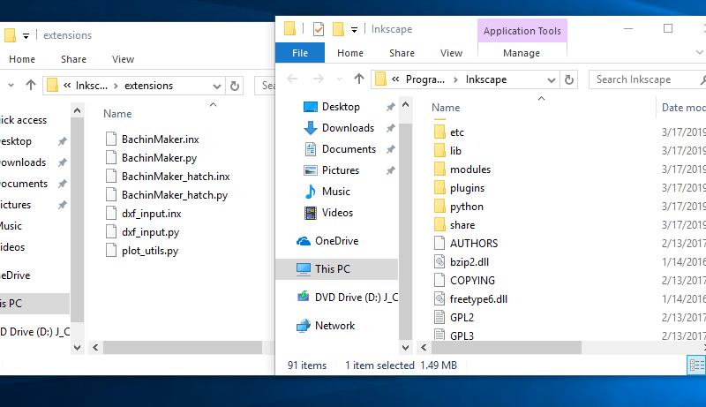

**Copy all files into [extensions]**

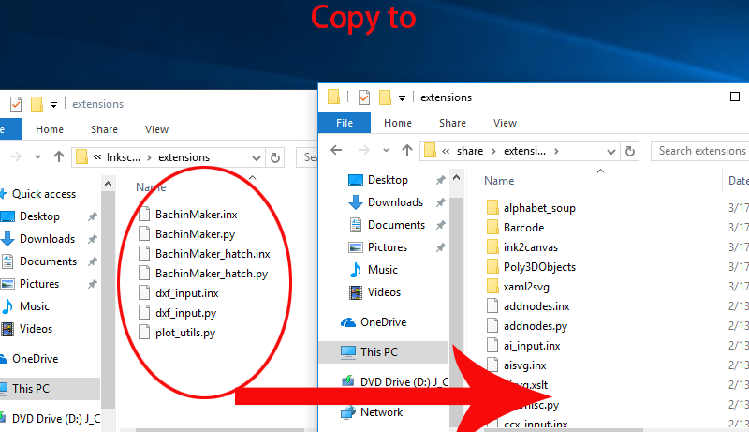

**Run Inksacpe, our tool is in the Extensions Menu.**

